Tagie 4 Manual Software Version 2.97
Quick Start
Tagie-4 is designed to be simple to use ‘out of the box’.
Tagie-4 is normally supplied with the internal battery fully charged, but we suggest you charge it for about 4 hours first. Simply plug in the charger to the right hand socket at the bottom of the handset. The left hand light on the keypad should illuminate, and will go out when the battery is fully charged.
Operation
Switch on the handset by holding down the bottom left button (left arrow) for a couple of seconds.
If radio devices are installed ie Bluetooth or Zigbee, the start-up will be slower as the software tests the radio devices for functionality.
Bluetooth and Zigbee (Option)
For Bluetooth we use Bluetooth version 4, which is the latest low energy version of Bluetooth and is only compatible with machines supporting Bluetooth 4. Windows 8 and Windows 10 support this standard, and it’s a major advantage on handheld devices as its lower power consumption increases battery life significantly. Please contact us for more details as it’s an evolving standard.
Bluetooth and Zigbee are factory fitted options, and can either be fitted when you purchase Tagie, or at a later date by returning the product to us.
Bluetooth is used for connectivity to PC’s and some types of weigh scales, and Zigbee is mainly used for non branded Weighing products. Its not normally much of an advantage to use radio links with the PC, USB is just as fast and cheaper.
The Tagie-4 handset supports simultaneous connections with USB, Bluetooth and Zigbee, along with RS232. It is possible to put together some quite sophisticated systems connected by radio in an affordable manner. Please contact us for details.
If radio devices are connected and active a small antenna symbol will be displayed on the very top line of the display.
The start up screen will display for a couple of seconds, showing the software version and some other information, such as the time. The screen will then change to the Configuration and Printing screen, from which you can change the handset configuration, set the time and date and print directly to an optional plug in printer. The standard factory defaults are fine and you DO NOT need to change any settings.
Assuming you have a tag to hand, hold the tag near the antenna, press the read button and release it.
The tag should read, the handset will beep, and tag screen will be displayed with the tag number at the top of the screen. If you try to read the same tag a second time the handset will beep twice and display a message at the bottom of the screen, Duplicated Tag.
To read another tag simply press the read button again. Each time a tag is read the tag is automatically saved in memory.
The tag screen displays at the bottom the TOTAL number of tags in the handset, the number of tags in a batch and the tag type. This line may vary a little bit depending on the software version.
That’s it really, you have now read and saved your tags and you can now print them or send them to the free PC application.
The tag screen is the centre of operations, and any of the handset features can be accessed from the tag screen.
_____________________________________________________________________________________
In More Depth
Each tag is stored with a Batch Name. The default batch name is Batch 1 and if all you want to do is read and store tags to meet the legal requirements then you can ignore batch names. This subject is covered in more depth later in the manual.
Weights
When you have read tag, the tag screen displays the tag number and you have the option of keying in weight if Kilos. Simple key the weight and press ok. Tagie 4 allows connection to a number of popular weigh scales, normally by a radio link such as Zigbee or Bluetooth.
Although the operation may vary slightly depending on the weigh scale, is you have this type of set up, after reading the tag you can press the OK button and the handset will ‘fetch’ the weight from the scales and store it with the tag number.
The handset stores the 4 latest weights along with the date the weight was taken. This enables the PC to calculate average daily weight gains, and the handset can calculate this as well.
Keying a Tag Number
There are occasions when you might want to enter a tag number manually, ie the tag could not be read because the tag is faulty. When you press the read button an message at the bottom of the screen shows ‘Acquiring Tag’ and a countdown in seconds.
If no tag is read then the top of the screen will display Tag: and no tag number. You can simply key a tag number here and press OK and a tag record for that number will be created. Note the tag number you have keyed will be ‘normalised’ by the program to ensure it’s 12 digits.
Tag Number Meaning
A tag number is effectively in two parts, the left hand 7 digits are the flock number, and the right hand 5 digits are the animal number unique to that flock number. Also stored on the tag a country code, which the originating country code the tag. For the UK its 826, which is displayed on the T4 as UK.
The tag also contains a species code (31 options) identifying whether the animal tag is for sheep, (cattle) etc. This subject is being endlessly discussed in the appropriate BS and ISO committees at the moment.
Deleting a Tag
This not really a very common operation in normal day to day operations, as the deleted tag needs to be ‘accounted for’. If an animal dies for example, its tag should be read and the animal marked on the handset as Dead. This information will be sent to the PC software.
To delete a tag, first read it, and delete its tag number using the delete button and press ok. The tag will marked as deleted and passed to the PC software as deleted to enable the PC data base to be updated if required.
Changing a Batch Name
Batch numbers are covered in more detail later in this manual. The batch name display on the Tag screen is the batch for that tag. When a tag is read the batch name given to the tag is the CURRENT system batch name. A tag can be a member of more than one batch, on current software versions up to 6. When dealing the market variation of this software where batch names are pen names, only 1 Batch Name per tag is permitted.
Batch Names
The software allows for 50 batch names. A batch name can used for a variety of purposes, and an Animal can be a member of up to six batches. And in its simplest form a batch name is used to ‘contain’ a number of animals, ie typically a group being sent to market etc. They can also be used to identify a group of animals given specific treatments where the batch name can describe the type of treatment.
The default on a new handset is for there to be 1 batch, named ‘Batch 1’. Any tags read will be placed into this default batch. If you have no interest in using batches, then this default will be fine for day to day use.
You access the batch list by pressing the Batch button on the keypad. A list of all the current batch names will be displayed, and to the left of the batch name will be the number of animals in a given batch.
The handset displays up to 4 lines of batch names in the first screen and 5 lines on subsequent screens. You can move down the list using the down arrow. To select a batch name as the current batch, click on OK and the line with the Cursor (black rectangle) will be selected as the current batch.
The Back button will return you to the home screen.
The top line of the first page of the batch list displays the current batch name and the cursor will be positioned on Add New: You can create a new batch name using texting techniques, the Home button allowing you change numeric to alpha mode. Press ok and the new name will added to the bottom of the batch list and will become the current batch.
Batches can be deleted by pressing the Batch button and moving down the list to batch you wish to delete. Press the delete button and the Batch will be deleted and any tags in that batch will removed from that batch. If the tags in the deleted batch are also in other batches, they will NOT be removed from those batches. If the batch contains tags that are ONLY members of that batch, when the batch is deleted those tags that are only members of that batch will also be deleted.
Adding More Information to a Tag
From the tag screen having first read a tag you enter more details about the animal.
Use the down arrow and the right and left arrows to select one of three boxes at the bottom of the screen.
Action Notes History
Notes
You can enter approximately 128 characters of information about each animal using texting techniques. The home key when pressed briefly will enable you to change from numbers to letters. When finished press OK.
History
History information is loaded from the PC, and cannot be edited, it is for information only.
Actions
Here you can enter additional information about the animal and set up alerts.
Spray Enter the spray on number for this animal
Fetus Enter the number of fetus at scan time.
Cull Enter 1 to mark this animal for culling
Dead Enter 1 to mark this animal as dead.
Shed Enter 1 to mark this animal for shedding, the handset will bleep 4 times when its tag is read
Alert Enter 1 to mark this animal for an alert, use notes to qualify the alert. The handset will bleep 8 times when the animals tag is read.
Handset Settings
From the home screen (use Back or Home to get there, and home must be held down for more than 2 seconds, its dual function with quick click to change from numeric to alpha in texting mode) press 4.
To clear the memory of all tags key the pass word number 143, and press OK. The memory will be cleared in a few seconds and the handset will beep when finished. ALL TAGS WILL BE DELETED, batch names will not.
You can set the time and date using the format:
010615 for a date of June 1st 2015
120000 for a time of midday.
You must enter time and date at the same time and press OK when finished. All tag reads are time and date stamped, as are all weight reads.
You can play with the display contrast between the value of 20 and 31, the defaults are normally fine, you must switch the handset off and on to see the effect 31 is darkest, 20 lightest..
Weigh Scales
Tagie-4 can support a number of different types of weigh scale. The default is the Allweigh scale, which is an economic and effective electronic device. Note that for all our weigh scale connections you must have either Bluetooth or Zigbee options fitted. Please contact us for details and other scales.
The Allweigh connection is nearly transparent to the user. This connection uses Zigbee, and connects automatically when the handset and the Scale is powered up. The handset will display a small flashing circle at the top right of the screen if the scale connection is working correctly. It will also display the Antenna symbols showing that the radio unit is active.
In operation you simply read the animal tag, and the handset will fetch from the scales the next valid weight. Scales normally only send a valid weight if the weight has been stable for 1 to 2 seconds. The weight will be entered in the weight position on the tag screen and automatically saved. To re-weigh simple read the tag again.
Special Functions
These functions are not normally used for day to day use:
Start Up
If prior to switching on the handset you hold down:
2 Which will set factory defaults, does not delete tags or batch names but also sets time and date
4 A specialised calibration function only use to check electronically the FDX reading.
6 Resets all the batch names and sets one default batch name of Batch 1
7 Fills the batch name list with Batch 1 to Batch 51.
Memory
Instead of using 143 to clear the tag memory you can use 144. This is a sort of deep CLEAN, much slower, about 1 minute.

Charger, Printer and USB sockets

When you remove the base plate from your Tag-ie 4, it will look like this.
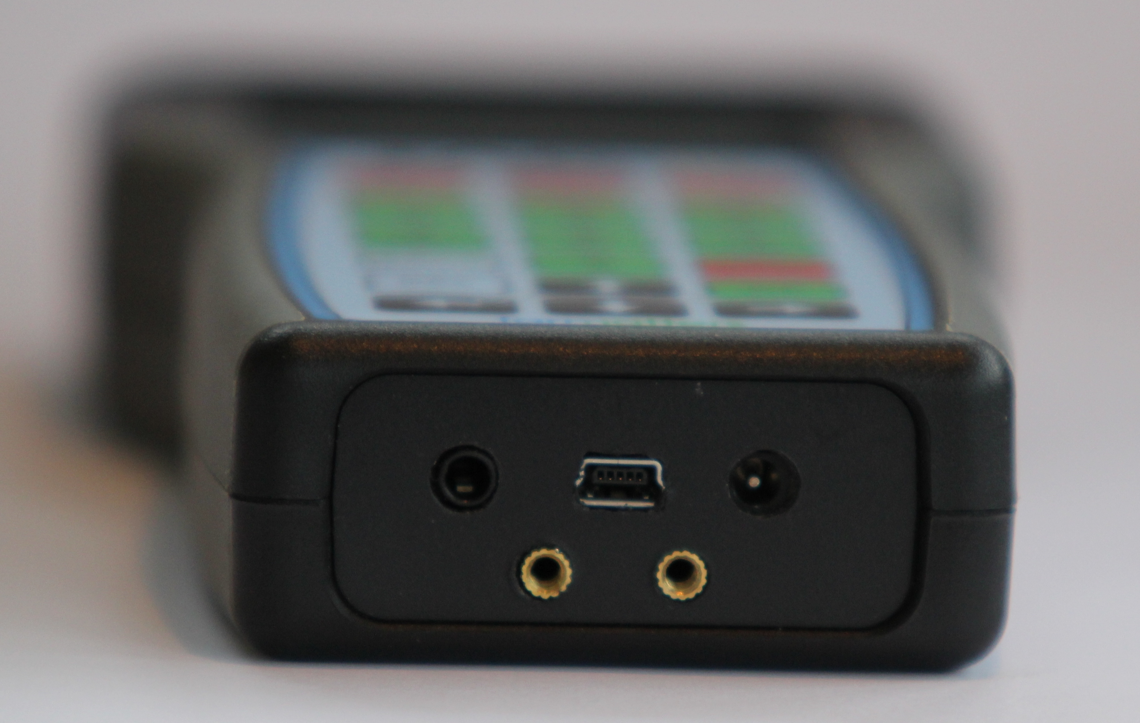

The right hand socket is to plug in the Tag-ie 4 charger.
The centre socket is for the PC to Tag-ie 4 USB lead.
The left hand socket is for a Tag-ie 4 to portable printer lead (not supplied unless you have purchased a portable printer with your Tag-ie 4 handset)

Our Contact Details

Grovedime Ltd
Hillside
Bridestowe
Okehampton
Devon EX20 4EN

Tel: 01837 861786
www.tag-ie.co.uk

